* Added payment options (4:29 pm 5 - 15 - 22)
* Added validation for payment option (7:06pm 5 - 15 - 22)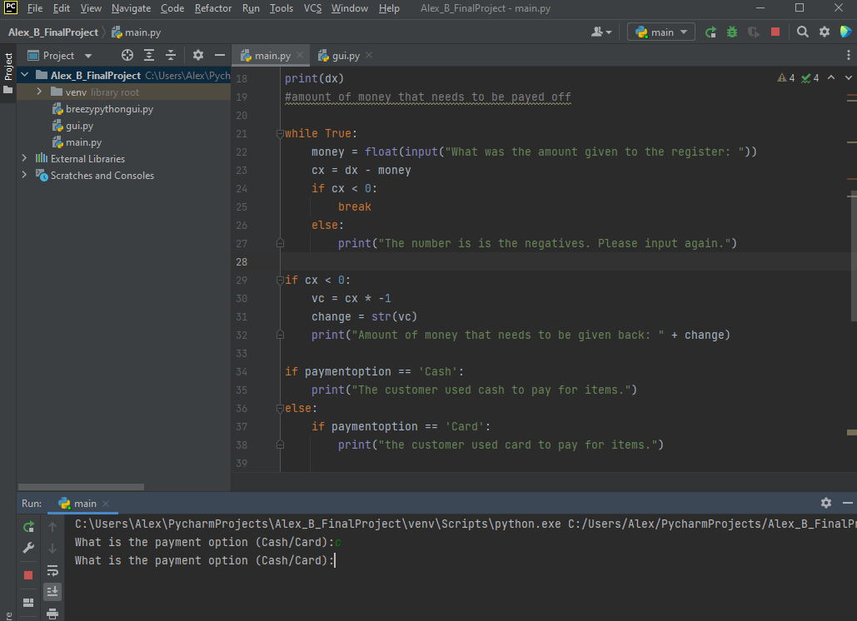
  + Had trouble figuring out the breaks for some reason
* Added validation for the cost of the items (7:10 pm 5 - 17 - 22)
* 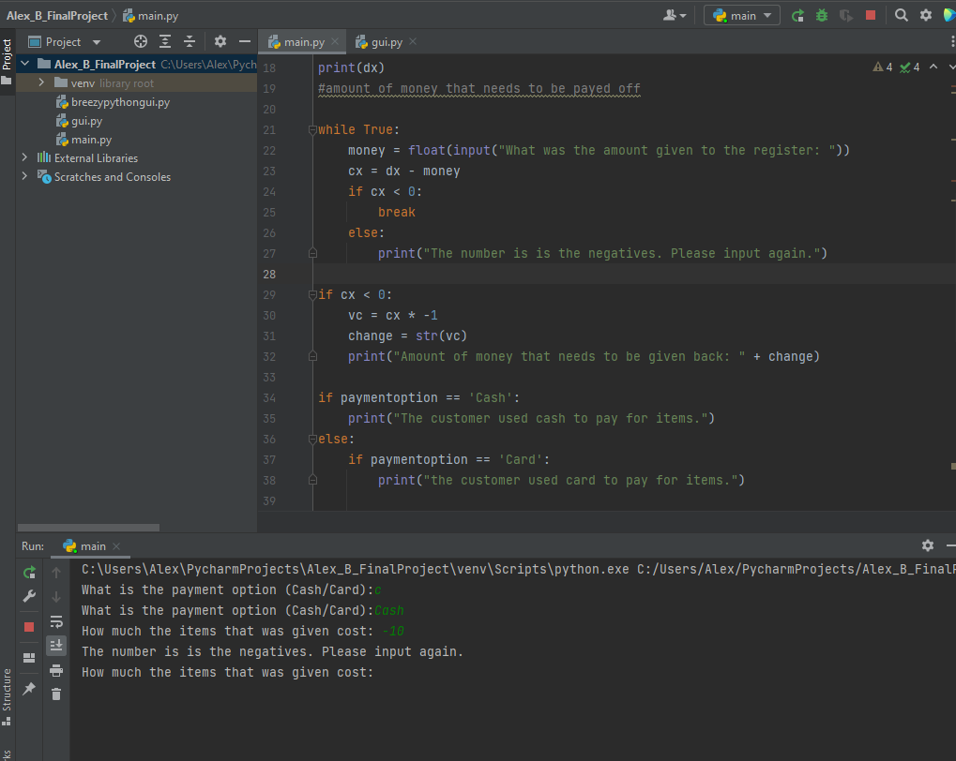
* Added validation for the amount given to the register (7:17 pm 5 - 17 - 22)

